1. **Theoritical Background and Literature Review**

**1. Artificial Intelligence (AI) Overview**

Artificial Intelligence (AI) is the field focused on creating systems capable of performing tasks that typically require human intelligence, such as reasoning, perception, and decision-making. Modern AI has evolved from rule-based systems to data-driven machine learning, with recent breakthroughs driven by large-scale deep learning models, especially transformers. Large language models (LLMs) such as GPT, Llama, Claude, and Gemini now function as versatile reasoning engines, capable of processing text, code, and multimodal inputs.

Multimodal AI extends these capabilities further by handling text, audio, images, and video within unified pipelines, enabling applications such as lecture transcription and analysis. Techniques like retrieval-augmented generation (RAG) improve accuracy by linking models to external knowledge sources, while parameter-efficient fine-tuning methods (e.g., LoRA) allow cost-effective customization for domain-specific tasks. Advances in generative AI also include powerful text-to-image, audio, and video models, expanding creative and analytical possibilities.

Longer context windows and agent-like tool usage enhance AI’s ability to work with large, complex datasets, such as full lecture transcripts. Alongside these capabilities, there is a growing emphasis on safety, alignment, and governance frameworks to ensure responsible deployment, especially in sensitive domains such as education.

**2. AI-Generated Quiz Creation Process**

AI-generated quizzes are created through a multi-step process combining content extraction, knowledge understanding, and question formulation. Initially, the system ingests source material, including lecture transcripts, documents, audio recordings, or videos. For non-text inputs, automatic speech recognition (ASR) converts audio to text, while optical character recognition (OCR) extracts text from images or slides.

The extracted text undergoes natural language processing (NLP) to identify key concepts, relationships, and learning objectives. Summarization models condense large content into focused sections, and retrieval-augmented generation (RAG) ensures that generated questions are grounded in the original material. Large language models (LLMs) such as GPT or LLaMA, often fine-tuned with educational datasets, transform these concepts into various question formats, including multiple-choice, fill-in-the-blank, true/false, and short answer.

Dynamic difficulty adaptation is possible based on frameworks like Bloom’s Taxonomy or student performance data. Platforms such as Questgen AI, Quizbot AI, and VidVersityQG demonstrate these capabilities, supporting multimodal inputs and customizable outputs. This process not only automates assessment creation but also personalizes quizzes for targeted revision, making it a valuable technology in modern education.

**3. AI Multimedia Generating Tools**

**3.1 Overview**

AI multimedia tools refer to artificial intelligence systems designed to automate or assist in the creation of various media types, including text, images, audio, video, animation, and interactive content.  
Multimedia, in general, combines multiple forms of content—such as text, images, audio, and video—into a unified presentation to create richer and more engaging user experiences. Interactive multimedia enables active user participation through features like clickable elements, quizzes, and games, making content more dynamic and personalized.  
With advancements in AI, content generation has evolved significantly. Natural Language Processing (NLP) enables AI to produce structured and coherent textual content, such as articles, reports, and blog posts. Generative Adversarial Networks (GANs) and other generative models facilitate the creation of realistic images, while AI-driven tools support music composition, sound editing, voice synthesis, video production, and animation. Collectively, these innovations reduce manual workload, enhance creative efficiency, and enable personalized multimedia experiences.  
**Reference:** Wikipedia, *Multimedia*; AIPLUSINFO, *AI’s Influence on Media and Content Creation*

**3.2 Text-to-Text Generation Models**

Text-to-text AI models, such as ChatGPT, generate coherent text from natural language prompts and have significant educational implications. These tools enable rapid production of essays, code, and assignments, raising concerns about academic integrity as students may submit AI-generated work without learning.

ChatGPT uses transformer architecture to maintain context and produce fluent responses but can also generate incorrect or fabricated information, including fake academic references. Traditional plagiarism detection tools struggle to identify such content.

Digital watermarking has been proposed as a detection method, embedding hidden patterns in AI-generated text to enable identification. However, this approach is not foolproof, as students can alter the text to avoid detection, and access to detection tools may be limited.

To address these challenges, institutions should develop flexible policies, provide training for students and staff on ethical AI use, and redesign assessments to reduce misuse. Human judgment remains crucial for detecting AI-generated content. Engaging students in policy-making and adopting a collaborative community approach are essential to maintaining academic integrity in the AI era.

**3.3 Text-to-Image Models**

Text-to-image models are AI systems capable of generating images directly from natural language descriptions. They bridge linguistic and visual modalities, enabling users to produce visuals that align with specific prompts.  
Current approaches include:

1. **Generative Adversarial Networks (GAN-based)** – Utilizes a generator–discriminator framework to produce realistic images that align with text descriptions.
2. **Diffusion Models** – Gradually transform noise into coherent images using denoising steps guided by the prompt; exemplified by *Stable Diffusion* and *DALL·E 2*.
3. **Transformer-based Models** – Leverage transformer architectures to model relationships between text and visual components, allowing fine-grained image control.
4. **Hybrid Approaches** – Combine multiple techniques to maximize both visual quality and semantic accuracy.  
   Applications include digital art, marketing, product design, and educational content creation.  
   **Reference:** arXiv, *Text-to-Image Generation Models*

**3.4 Text-to-Audio/Voice Models**

These AI systems generate speech, music, or sound effects from textual input, enabling applications like voice assistants, audiobooks, and music composition. Examples include Google WaveNet and Uber’s Jukebox.

**3.5 Text-to-Video Models**

Emerging AI tools create video content from text descriptions or minimal inputs, automating video production aspects. Though still developing, platforms like Runway Gen-2, Meta’s Make-A-Video, and Google’s VEO 3 demonstrate early capabilities.

**3.6 Use Cases in Education**

Text-to-image models can enhance education by producing rich, context-specific visual materials tailored to various learning styles, improving comprehension and engagement.

* **Educators** can create custom illustrations, diagrams, and infographics aligned with lesson objectives, reducing the need for manual design.
* **Students** can visualize abstract concepts, historical events, and scientific processes, aiding retention and fostering creativity.
* **Creative Fields** such as art, design, and media studies can integrate these tools into coursework to inspire innovation and develop visual communication skills.
* **Inclusive Education** benefits through culturally relevant and accessible imagery adapted for different linguistic contexts and students with disabilities.  
  Overall, these models bridge the gap between abstract concepts and tangible understanding.

Diagram: (Student AI Usage Statistics – Digital Education Council Global AI Student Survey, 2024)

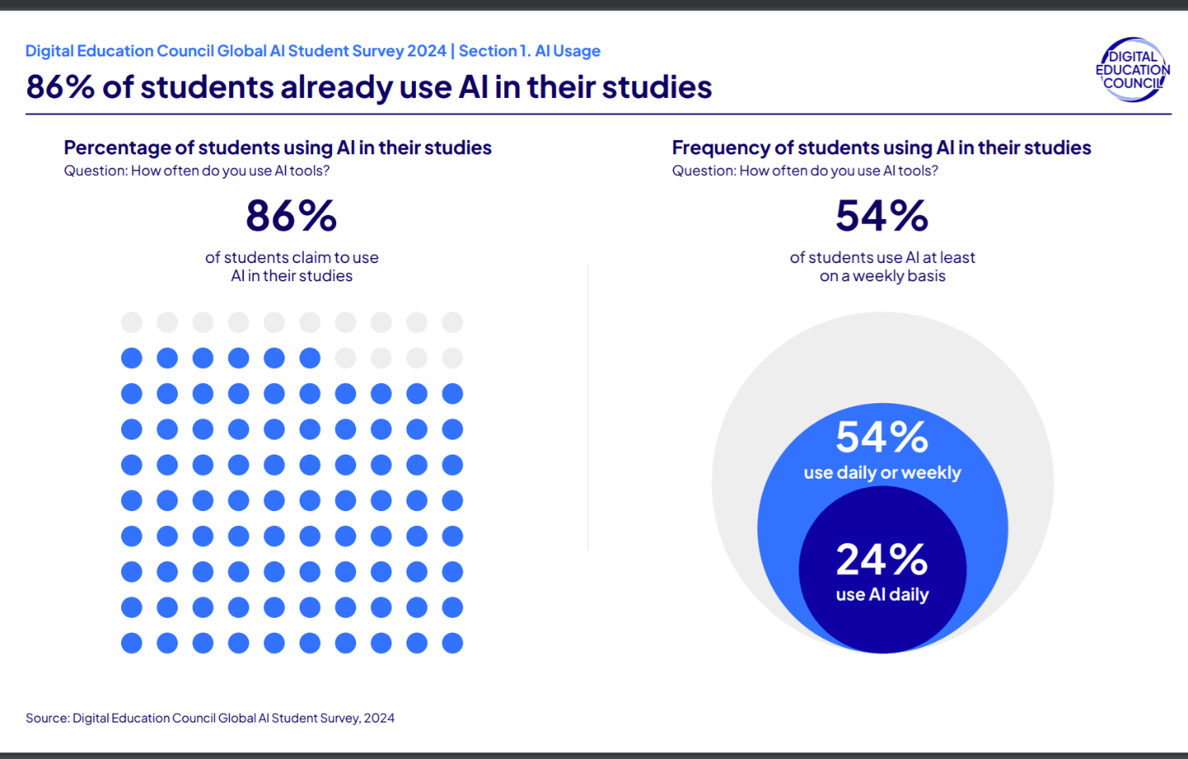

* **86%** of students already use AI in their studies.
* **54%** use AI daily or weekly, with **24%** using it daily.  
  This indicates AI is a mainstream tool in modern learning environments.

**Diagram: (Future AI Use in Classrooms – Forbes)**

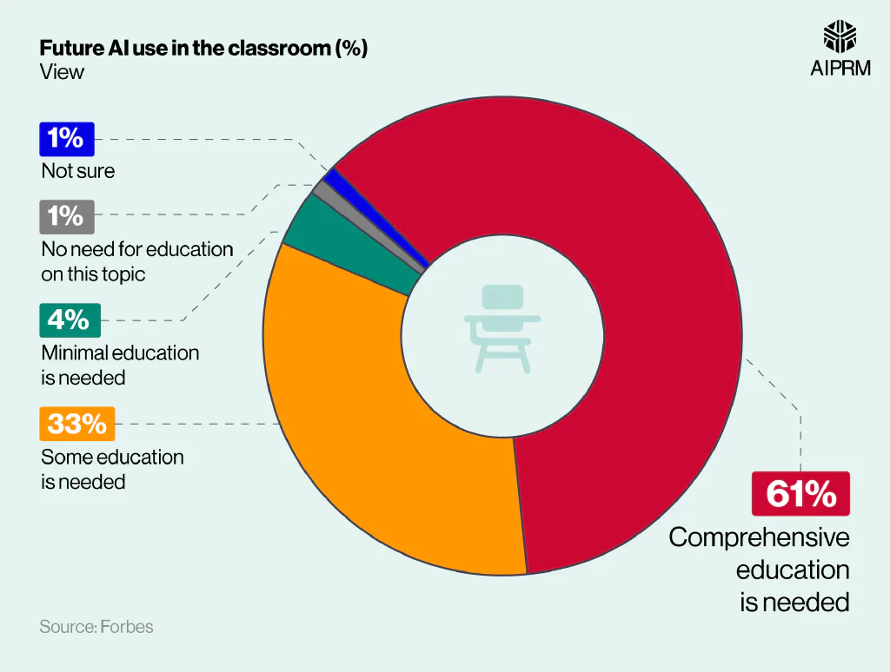

* **61%** believe comprehensive AI education is necessary.
* **33%** believe some education is needed.
* **4%** believe minimal education is needed.
* **1%** see no need; **1%** are unsure.  
  This reflects strong consensus on the need for AI literacy in education.

**3.7 Challenges and Ethics**

Despite the promising capabilities of AI multimedia tools, several significant challenges and ethical concerns must be addressed to ensure their responsible use.

One major challenge involves the **quality and reliability** of AI-generated content. Models sometimes produce inaccurate, biased, or misleading outputs, which can affect the credibility of educational materials or media productions. These errors may arise from biased training data or inherent model limitations.

**Bias and fairness** constitute another critical issue. AI systems often reflect societal prejudices present in their datasets, risking the perpetuation of stereotypes or discrimination, particularly in culturally sensitive content. This concern is especially relevant in educational contexts where inclusivity and equity are paramount.

**Copyright and intellectual property rights** also pose challenges. The generation of images, videos, or music by AI may inadvertently infringe upon existing works, raising legal and ethical questions regarding ownership and proper attribution. Clear guidelines and regulations are still evolving in this area.

Moreover, the misuse of AI tools for **creating deceptive content**, such as deepfakes or fabricated news, threatens trust and can lead to misinformation. This necessitates the development of robust detection methods and ethical standards to mitigate harm.

Finally, issues of **data privacy** and **user consent** arise when AI models are trained on or utilize personal or sensitive information, calling for transparent data practices and compliance with regulations like GDPR.

Addressing these challenges requires multidisciplinary collaboration between technologists, educators, policymakers, and ethicists to establish frameworks promoting transparency, accountability, and fairness in AI multimedia applications.

**3.8 Summary**

AI multimedia generating tools are transforming how content is created, distributed, and consumed. From text-to-image applications enhancing classroom learning to predictive models shaping personalized media experiences, these technologies offer vast potential but also require ethical consideration. Their integration into education not only improves efficiency and creativity but also raises the need for comprehensive AI literacy.

**4. AI Tools to Generate Quizzes**

**4.1 Introduction**  
The advancement of artificial intelligence (AI) has significantly transformed educational assessment by enabling the automated generation of quizzes. AI-driven quiz generation tools leverage natural language processing (NLP) and machine learning (ML) algorithms to create diverse and potentially personalized assessments tailored to individual learner needs. These tools hold promise for improving instructional efficiency, providing immediate feedback, and supporting adaptive learning environments. This section explores the fundamental mechanisms behind AI quiz generation, the variety of question types produced, as well as the key benefits, challenges, and limitations associated with their educational deployment.

**4.2 How AI Quiz Tools Work**  
AI quiz generation systems utilize a combination of Natural Language Processing (NLP), Machine Learning (ML), and large language models (LLMs), such as GPT, to automatically formulate questions from educational content. NLP techniques enable these systems to parse and understand text, extract key concepts, and discern relationships between ideas. ML algorithms analyze patterns in existing question banks and learner performance data to generate contextually relevant and well-structured questions. More sophisticated tools employ LLMs capable of synthesizing novel content, paraphrasing complex concepts, and modulating language complexity to suit the target audience. These systems accept varied input formats—including documents, lecture transcripts, or video content—and transform them into diverse question types, such as multiple-choice, true/false, open-ended, and scenario-based items. Typically, a validation phase ensures that generated questions align with learning objectives and meet standards of clarity and accuracy prior to delivery.

**4.3 Types of Questions Generated**  
AI-powered quiz tools produce an array of question formats, each fulfilling specific pedagogical roles. Multiple-choice questions (MCQs) are predominant, assessing recognition and recall by presenting learners with several options and a single correct response. True/false questions serve to quickly evaluate binary knowledge statements, facilitating rapid assessment of factual understanding. Short-answer questions encourage active recall and comprehension by requiring concise learner responses. More advanced AI systems can generate open-ended or essay-style questions that assess higher-order cognitive skills such as critical thinking, synthesis, and application. By encompassing a spectrum of question types, AI-driven quiz platforms support a broad range of learning objectives and assessment strategies.

**4.4 Personalization and Adaptivity**  
Despite significant advancements, most AI quiz generation tools currently offer limited or no meaningful personalization and adaptivity. Predominantly, these tools deliver static quizzes that neither adjust question difficulty nor alter topic focus based on individual learner performance or preferences. Feedback mechanisms remain basic, often failing to provide actionable guidance to support learner progress. This lack of dynamic adaptation results in generic learning experiences that underutilize AI’s potential to tailor assessments to individual needs, thereby constraining the effectiveness and engagement of educational activities.

**4.5 Challenges and Limitations**  
While AI quiz tools can generate questions with relative ease, a common limitation lies in the generation of coherent and contextually relevant multiple-choice options. For instance, it is not uncommon for tools like Quizlet and Quizziz to produce distractors that are unrelated to the question stem—such as pairing a date-related question with options including ocean names or irrelevant phrases—thereby undermining the assessment’s validity. Additionally, many tools impose strict character limits on questions and answer choices, which restricts complexity and hinders clarity. The inability to adjust question difficulty is also widespread, limiting these tools’ utility for accommodating learners with diverse skill levels. Collectively, these issues diminish the overall quality, reliability, and pedagogical value of AI-generated quizzes.

**4.6 Future Trends**  
One of the most promising developments in AI quiz generation is the increased adoption of advanced large language models (LLMs) such as GPT, Gemini, and related technologies. These models demonstrate superior capability in producing high-quality quiz questions and can adapt difficulty levels contextually, enabling more personalized learning experiences. However, despite their strengths in content generation, LLM-based quizzes often remain static, lacking interactive and real-time adaptive features that are essential for fostering learner engagement and providing immediate, dynamic feedback. Future research and development efforts are expected to focus on integrating LLMs with interactive assessment platforms, thereby enhancing adaptivity and creating more immersive, responsive educational experiences.

**References**

* OpenAI. (2025). Introducing GPT-5. <https://openai.com>.
* Meta AI. (2024). Llama 3 models. <https://ai.meta.com/llama>.
* Google DeepMind. (2024). Gemini 1.5 announcement. <https://deepmind.google>.
* Anthropic. (2024). Claude 3 family. <https://www.anthropic.com>.
* Yin, W. et al. (2024). A Survey on Multimodal Large Language Models. <https://arxiv.org/abs/2401.13601>.
* Lewis, P. et al. (2020). Retrieval-Augmented Generation for Knowledge-Intensive NLP. <https://arxiv.org/abs/2005.11401>.
* Hu, E. et al. (2022). LoRA: Low-Rank Adaptation of Large Language Models. <https://arxiv.org/abs/2106.09685>.
* Questgen AI. (2025). AI-Powered Question Generation Platform. <https://www.questgen.ai>.
* Quizbot AI. (2025). Automated Quiz Creation Tool. <https://quizbot.ai>.
* Shahid, O., Hussain, S., & Shoaib, M. (2021). VidVersityQG: Automated Video-based Question Generation for Education. <https://arxiv.org/abs/2112.01229>.
* Quizaic: A Generative AI Case Study. Medium. <https://medium.com/google-cloud/quizaic-a-generative-ai-case-study-190b02baa8df>.
* ChatGPT, OpenAI language model responses and related documentation.
* Observations from Quizlet, Quizziz, Kahoot, QuestionPro, and ProProfs platforms.
* Alsmadi, I., & Almarashdeh, I. (2023). Artificial intelligence applications in education: A review of current trends and future perspectives. Education and Information Technologies, 28(4), 4513–4532. <https://doi.org/10.1007/s10639-022-11298-4>.
* Chen, Y., & Wang, X. (2022). Enhancing learning engagement through AI-assisted content creation. Computers & Education, 181, 104453. <https://doi.org/10.1016/j.compedu.2022.104453>.
* Kovačević, A., & Li, J. (2023). The role of generative AI in personalized education. British Journal of Educational Technology, 54(5), 1290–1307. <https://doi.org/10.1111/bjet.13315>.
* Zhang, M., & Lee, D. (2021). Artificial intelligence for multimedia-based education: Opportunities and challenges. Interactive Learning Environments, 29(7), 1132–1149. <https://doi.org/10.1080/10494820.2019.1703012>.
* UNESCO. (2023). Guidance on the ethical use of artificial intelligence in education. Paris: UNESCO Publishing. <https://unesdoc.unesco.org>.
* Hao, K. (2019). AI is sending people to jail—and getting it wrong. MIT Technology Review. <https://www.technologyreview.com/2019/01/21/137783/ai-is-sending-people-to-jail-and-getting-it-wrong/>.